Note: This is not the latest version. The final version can be accessed through link:-
https://drive.google.com/drive/folders/1saGHnuB-rvRVhnCkKESmjSiIK53q4PSt?usp=sharing

TITLE
Develop automatic literature mining tool for extracting context specific glycan-protein data that will enhance the extent and quality of data in GlyGen.

ABSTRACT

GlyGen is an international glycoinformatics project developed to facilitate glycobiology research through data integration and data management of different glycan-protein databases. The major resources for site-specific protein-glycan data in GlyGen are UniCarbKB, GlyTouCan, and UniProtKB. Currently, the amount of glycan-protein data that has been extracted and is available in these databases or other similar resources is quite limited. With the new technological advancements in the field of glycobiology, there is a huge influx of data generated through publications that need to be captured and made publicly available. Leveraging our previous work in developing similar tools such as RLIMS-P (Rule-based Literature Mining System for protein Phosphorylation), we propose to develop a text-mining tool to capture glycobiology data from new and existing publications. We intend to capture all relevant information specific to glycosylation by focussing on all aspects such as; glycoprotein (expression system, source, species etc), mass spectrometry data (analyzer, proteolytic enzymes etc.), glycan (structure, composition etc.) and residue information (site, amino acid etc). The data gathered through this proposal will increase the existing glycobiology knowledge and will be publicly available through integration into GlyGen.

NARRATIVE

The proposed method creates a comprehensive database of site-specific, protein-glycan information, which can be easily accessible through GlyGen. The replicability and usability of this tool will further enrich the existing data in GlyGen by providing novel annotations as well as help capture the increasing information in glycobiology presented through new publications.

AIMS

Glycosylation is one of the major post-translational modifications as it affects several protein properties such as protein folding, stabilization, interactions, pharmacokinetics, immunogenicity, bioactivity etc. [PMID: 9890515, PMID: 1478359]. Changes in glycosylation have been linked to several diseases such as cancer [PMID: 25621663]. Over the last several years, there has been a significant contribution to the field of Glycobiology through different groups. This is due to the combination of technological advancements and a growing need to explore the glycan-protein relationship. Therefore, it has become increasingly important to capture and transform this data into glycobiology knowledge. Based on our experience in developing similar tools, we propose to develop a text-mining tool as a method to capture site-specific, glycan-protein data from publications.

Following are the major aims we plan to achieve during the 2-year span of this project.

Aim 1: Develop and run literature mining software that can extract information from publications that can be used to improve GlyGen content.
a) Use automatic literature mining tool on the existing papers in GlyGen (sourced from UniCarbKB and GlyTouCan) as a method to provide quality control and assurance as well as capture novel annotations to the existing data.
b) Increase site-specific and protein specific glycan data in GlyGen by adding new annotations, glycoproteins, glycosylation sites, and glycan structures through literature mining of new publications.

Aim 2: Replicability and usability of the tool.

a) Provide literature mining software as a deliverable so that it can be run automatically on new publications.
b) Generate a dictionary of glycan string to GlyTouCan accession as a way to assign GlyTouCan accession to the composition format of the glycan present in the publication.

The extracted data, as well as data generated through inference, will be represented as GlyGen data objects and will be accessible through GlyGen Data page (http://data.glygen.org/browse). The data will also be accessible through GlyGen protein and glycan search pages (http://glygen.org) where users can perform additional queries, searches as well as view and download the data.

RESEARCH STRATEGY

Background and significance

Microheterogeneity is one of the most common and important feature of protein glycosylation. It suggests that multiple glycan structures can be observed at a specific glycosylation site on the same protein expressed in the same cell type. This variation increases when extended to a different site, cell type or a protein. Thus, the same glycoprotein can exist in different “glycoforms”. [PMID: 20301239]. This results in a distinct glycome for each microenvironment [PMID:20301239], making glycosylation one of the most complex post-translational modifications. In order to completely understand this phenomenon, it is necessary to analyze all components of glycosylation such as cell, protein, glycan, and site. Therefore, it is important to capture different glycoforms reported experimentally through publications. Given the increased curiosity to understand the role of glycosylation, the number of glycobiology specific publications have increased over the last several years (see Fig. 1). Capturing and generating an extensive site-specific protein-glycan database will be an initial effort necessary to understand the heterogeneity of this biological process.
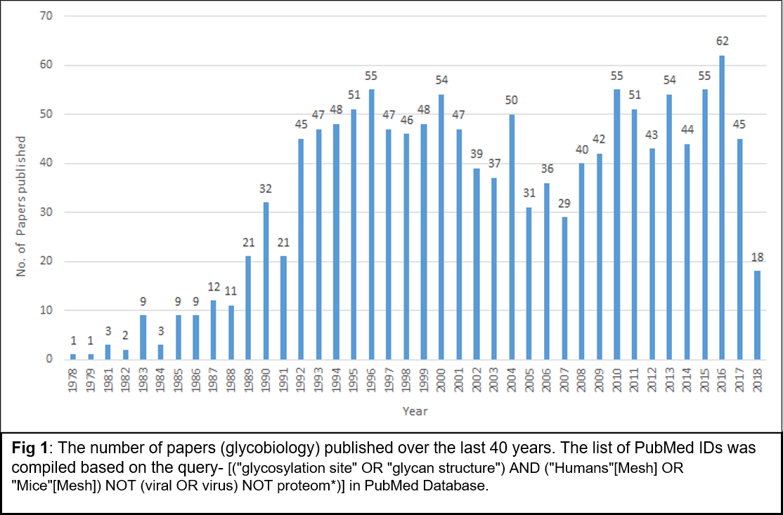

Research Team

Approach

We aim to retrieve the selected information (see table 1) from approximately 2,278 papers which represent new and currently included papers in GlyGen (as present on 12/5/18). Literature mining on the existing 801 papers will add new annotations such as expression system of the glycoprotein, site occupancy, glycan to site specificity, predominant glycan species, negative information and connection of glycosylation to a disease, previously not captured in GlyGen. In addition to these new annotations, literature mining will also provide an additional level of verification to the existing data, generated by several curators or sources over different periods of time. The list of 1,477 new papers was estimated based on a conserved “Text word” (mass spectrometry of glycans, human glycoprotein, structural characterization of glycans, characterization of glycosylation sites) and “Mesh” [("glycosylation site" OR "glycan structure") AND ("Humans"[Mesh] OR "Mice"[Mesh]) NOT (viral OR virus) NOT proteom*)] search in PubMed database.

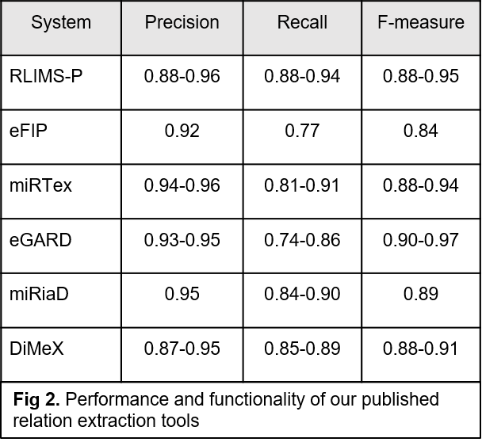
Development of the text mining tool for this project will be based on our experience in developing RLIMS-P (Rule-based Literature Mining System for protein Phosphorylation), currently being extended for other PTMs including glycosylation. To extract information from research literature on a large-scale, we have developed several RE tools. Some of these tools relevant to this project have been applied on entire Medline and entire PMC open access (OA) articles to extract specific relations. We have successfully developed several PTM-focused text mining tools (Fig 2) using our state-of-the-art NLP approaches, including RLIMS-P [PMID: 15814565, 25122463, 15961474, 16644790] for mining phosphorylation events (kinase, substrate, and site) and eFIP [PMID: 23221174, 25833953, 21082428] for mining the impact of phosphorylation on substrate protein interactions. The tools have achieved high precision, have been evaluated in the BioCreative Interactive Task for usability and utility [PMID: 25122463, 25833953, PMID: 23327936] and are being adopted for computer-assisted literature-based curation by a growing number of databases and ontologies (e.g., Phospho.ELM [PMID: 21062810], PhosphoGRID [PMID: 23674503], Gallus Reactome [85] and PRO [PMID: 24270789]). To capture disease/cancer-related context, we have developed two extraction tools: miRiaD [PMID: 27216254], which extracts miRNA target and expression as well as the impact on processes in the disease context, and DiMeX [27073839], which mines disease associations with mutations. Additionally, DEXTER [PMID: 29860481] was developed to extract differential expression in disease/tissues and eGARD [PMID: 29261751] to extract association of genomic anomalies with drug responses).

Aim 1: Develop and run literature mining software that can extract information from publications that can be used to improve GlyGen content.

Aim 1a) Use automatic literature mining tool on the existing papers in GlyGen (sourced from UniCarbKB and GlyTouCan) as a method to provide quality control and assurance as well as capture novel annotations to the existing data.

The tool will intend to capture the selected data (see Table.1) from the publications (PMC open access only). This data will be validated using the existing data as part of the QA/QC process. Additional annotations such as expression type (tissue, cell type etc) of the glycoprotein, proteolytic enzymes, connection to disease etc. will be captured wherever provided.
Details of the process are as follows:

- Literature mining of the existing papers (PMC open access only) in GlyGen.
- Evaluating and choosing an appropriate pdf to text converter.
- Building and refining the text-mining functionality.
- Extracting contextual information such as tissue/ organ/ cell-line (where the glycosylation was observed) as well as the disease information.

Aim 1b) Increase site-specific and protein specific glycan data in GlyGen by adding new annotations, glycoproteins, glycosylation sites, and glycan structures through literature mining of new publications.

Selected data (see table 1) for new glycoproteins will be captured and mapped to the UniProtKB accessions through inference. The tool will be developed to capture glycan composition and mass spectrometry data (such as analyzer, sample preparation method, mass of glycan and glycoprotein etc.) through tables and figures. Details are as follows:

- Extending the text-mining functionality to new publications.
- Developing new functionality to extract non-textual information from the papers; such as:
  - Relevant information from the tables.
  - Glycan structure/composition and mass spectrometry analysis data from figures.

Aim 2: Replicability and usability of the tool.

Aim 2a) Provide literature mining software as a deliverable so that it can be run automatically on new publications.

A Docker container along with appropriate documentation will be set up as an effort to use this tool on new publications.

- Establishing a Docker container in GlyGen Github repository as a way to provide the ability to use the tool on new publications.
- Provide supporting documentation.

Aim 2b) Generating a dictionary of glycan string to GlyTouCan accession as a way to assign GlyTouCan accession to the composition format of the glycan present in the publication.

Using the glycan structure specific publications from GlyTouCan, a dictionary mapping the IUPAC (or any other similar composition format) to GlyTouCan Accession will be generated. This will provide a reference for glycan composition to GlyTouCan Accession mapping.

Overview of the process

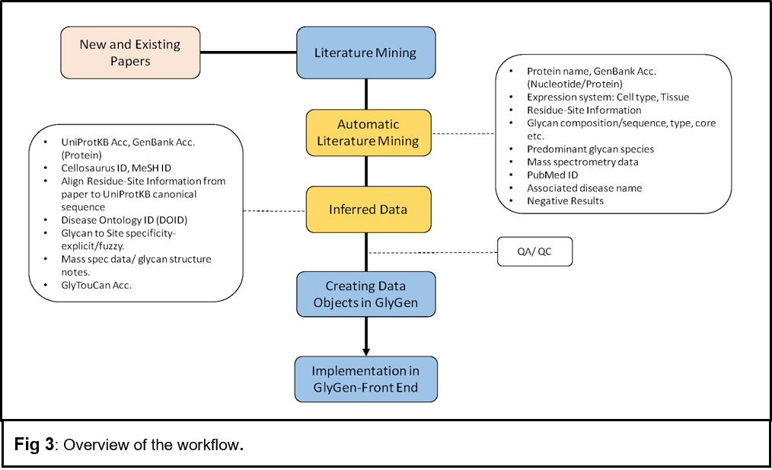

Extraction of specific data from publications

We plan to extract the following information with respect to glycosylation for human [taxid:9606] and mouse [taxid:10090] species through this tool:

A] Data captured through Automatic Literature Mining:

- Glycosylated protein
  - Protein name
  - Cell-type or tissue from which the protein was expressed (Expression system)
- Glycosylation site for the protein
  - Residue (e.g. Ser or Thr or Asn)
  - Position
  - Type of linkage/ glycosylation (e.g. N-linked or O-linked).
  - Site occupancy (Percentage of protein population with glycosylation site utilized).
- Glycan information
  - Composition (e.g. IUPAC sequence of the glycan)
  - Glycan core type (eg. Hybrid / Complex / High-Mannose)
  - Link sugar (e.g. GlcNAc, GalNAc)
  - Predominant/ most abundant glycan species.
- Mass spectrometry analysis information/details: (Glycopeptide/glycan)
  - Sample preparation method
  - Mass
  - Analyzer
  - Ionization
  - Chromatography
  - Lectin characterization
  - Fragmentation
- Evidence:
  - PubMed ID
- Connection to disease (e.g. type of cancer).
- Negative results (e.g. Potential glycosylation site which was never found to be glycosylated).

B] Data will be inferred through new and existing tools:

- UniProtKB accession or RefSeq Accession
- Mapping residue position from paper to UniProtKB canonical sequence
- Cellosaurus ID
- Human Disease Ontology ID (DOID)
- GlyTouCan Accession
- Glycan-site specificity (‘site-specific’ if the glycan is attached to a specific site on a protein or ‘multiple’ if the glycan could be present on one or more of the reported glycosylation sites).

Table 1: Example row from publication (PMID: 8142896). The highlighted text represents inferred data.

Field | Value
Glycosylated protein-
Protein name | human interferon $γ$ receptor
UniProtKB accession | P15260-1
GenBank accession
Mass
Expression system (protein):
Tissue
Cell line | baculovirus-infected insect Sf9 cells
Cellosaurus Id | -
Glycosylation site-
Amino acid (Residue) | Asn
Position (position in the paper) | 17
Position (position in UniProtKB canonical sequence) | 34
Type of linkage/glycosylation | N-linked
Site occupancy (%) | 100
Glycan-
Glycan composition | Man$α$1,6(Man$α$ 1,3)Man$β$1,4GlcNAc$β$1,4(Fuc$α$1,6)GlcNAc
Glycan core (if no glycan composition) | -
Link sugar (if no glycan composition) | -
Predominant/ abundant glycan species. | The predominant species was a hexasaccharide of molecular mass 1,039, containing a fucose subunit linked to the proximal N-acetylglucosamine residue.
GlyTouCan accession. | G82348BZ
Mass spectrometry analysis information/details:
Mass Glycan | 1039
Mass Glycopeptide
Sample preparation | Coomassie blue staining| Proteinase K digest| alpha-fucosidase.
Glycosidase treatments | N-glycosidase| Alpha-fucosidase
Analyzer | TOF
Ionization | -
Chromatography | Reverse Phase Chromatography
Lectin characterization | -
Fragmentation | -
Glycan-site specificity (position in the paper) | Multiple (Asn-62| Asn-69| Asn-162)
Glycan-site specificity (position in UniProtKB canonical sequence) | Multiple (Asn-79| Asn-86| Asn-179)
Connection to disease
DOID
Evidence (PMID) | 8142896
Negative results (position in the paper) | Asn 223 was never found to be glycosylated
Negative results (position in UniProtKB canonical sequence) | Asn 240 was never found to be glycosylated

Developing and refining text mining tool:
We have extensive experience in developing algorithms, tools, and resources for relation extraction (RE) and mining information from text. We created a general framework named Extended Dependency Graph (EDG) [1] that incorporates linguistic principles to move from syntactic dependencies to more semantic predicate-argument dependencies that are crucial for various RE systems. EDG framework allows fast development of rule-based and helps machine learning-based RE systems as it abstracts away from textual variations when it builds its representation.
The workflow (see Fig. 3) will use the documents in the form of Medline abstracts or full-length PMC articles which will be converted to text using pdf to text conversion or XML parsing (if the text is a PMC open access article). These texts will undergo initial processing that includes splitting the text into sentences and tokenization. Additionally, the relevant text will be parsed using the Charniak–Johnson parser [2,3], with David McClosky’s adaptation to the biomedical domain[4]. The parsed structure will be converted into dependencies that will be manipulated in the RE stage. In addition, certain extra-syntactic information will be added to dependencies that will be useful for relation extraction. Simultaneously, using different named-entity recognition (NER) tools and normalization tools, various type of entity mentions (including genes, proteins, diseases, cell lines, tissues, modification sites) will be detected and normalized to standard ontological IDs. The text with dependencies and named entities will be input to our in-house developed relation extraction framework built using EDG. This RE framework requires relation specific lexico-syntactic patterns defined on lexical triggers, syntactic dependencies and the types of the arguments. Additional processing may be required to extract the exact argument from matched positions (e.g. disease from a named cell-line or from a genetic disease mention). The output can be produced in standard formats such as BioC [PMID: 24048470] and JSON.
In most of our tools, we have used a combination of a few methods (in-house, GNorm/Pubtator [5]) for gene and protein name detection and normalization. Protein site detection will be done using the technology we have developed for RLIMS-P. We have been extending RLIMS-P using the EDG relation extraction framework to other post-translational modifications, including glycosylation. This work will be completed, comprehensively evaluated and used for this project. We will need to extend this system to capture the type of linkage and site occupancy information. While developing the adaptation of RLIMS-P technology to extract glycosylation information, we have conducted preliminary work on glycan information such as the sugar and recognition of glycan chemical structure.
DEXTER’s relation extraction module (RE) will be applied with minor modifications to tailor it to the extraction of the expressed cell-type/tissue of the glycosylated protein. The connections to disease (e.g. cancer) will be extracted based on techniques that we had developed in the context of eGARD and miRiaD, which also include algorithms for disease selection and normalization to DOIDs. We have developed a modular negation detection system enabling it to be plugged into any EDG-based RE system with minimal effort. This negation system will be used to extract negative glycosylation information. The process to extract glycan information in a comprehensive manner will be a collaborative effort between researchers at George Washington University and University of Delaware.

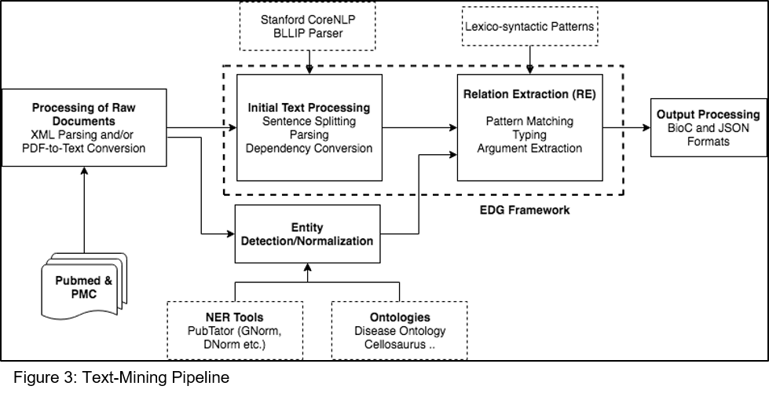

Presentation of the results in GlyGen:

New annotations will be integrated into GlyGen through new or existing sections /subsections on GlyGen Protein and Glycan pages: Examples for some of the data representation in GlyGen.

A] Glycan-site specificity and expression system (glycoprotein) will be integrated into the existing subsection
(With Reported Glycans) of the “Glycosylation” section and will be visible through GlyGen Protein page.

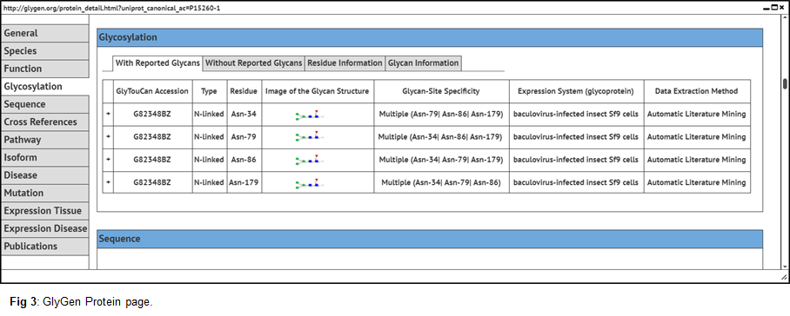

B] Site occupancy will be integrated into a new subsection “Residue Information” under the existing section - Glycosylation.

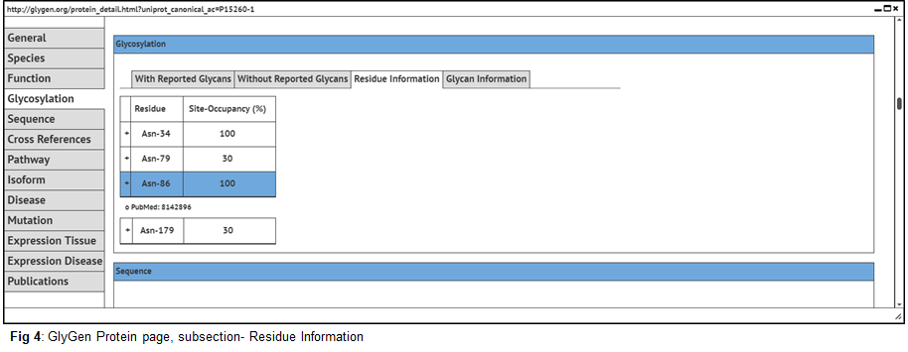

C] Information such as “Predominant glycan species” and “negative information” will be represented as literature comments through a new subsection (Glycan Information) under “Glycosylation” section.

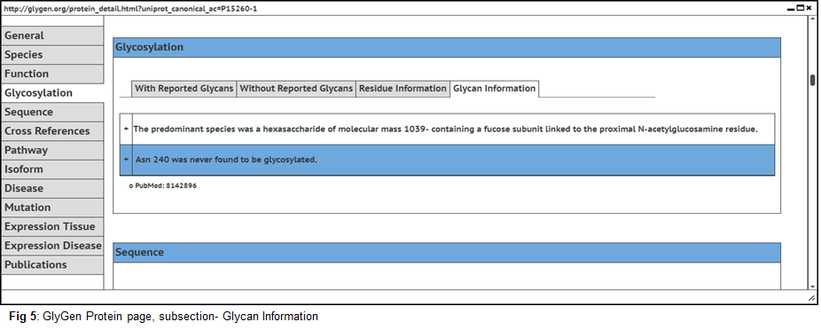

D] Disease information, as well as mass spectrometry data, will be represented in the existing protein page.

BUDGET DETAILS

Budget estimation: ~100K/yr for a 2-year span project.
Budget distribution:
Vijay Shanker: ~ 80K/yr
GWU: ~ 30K/yr

REFERENCES

1. Peng Y, Gupta S, Wu C, Shanker V. An extended dependency graph for relation extraction in biomedical texts. Proceedings of BioNLP 15. 2015; 21–30.
2. Charniak E. A Maximum-entropy-inspired Parser. Proceedings of the 1st North American Chapter of the Association for Computational Linguistics Conference. Stroudsburg, PA, USA: Association for Computational Linguistics; 2000. pp. 132–139.
3. Charniak E, Johnson M. Coarse-to-fine N-best Parsing and MaxEnt Discriminative Reranking. Proceedings of the 43rd Annual Meeting on Association for Computational Linguistics. Stroudsburg, PA, USA: Association for Computational Linguistics; 2005. pp. 173–180.
4. Mcclosky D. Any Domain Parsing: Automatic Domain Adaptation for Natural Language Parsing [Internet]. Brown University. 2010. Available: http://dl.acm.org/citation.cfm?id=2020153
5. Wei C-H, Kao H-Y, Lu Z. PubTator: a web-based text mining tool for assisting biocuration. Nucleic Acids Res. 2013;41: W518–22.

