Proposal:

With literature mining we aim to retrieve the following information with respect to glycosylation for human [taxid:9606] and mouse [taxid:10090] species:

- Glycosylated protein
  - Protein name
  - Cell-type or tissue from which the protein was expressed (Expression system)
- Glycosylation site for the protein
  - Residue (e.g. Ser or Thr or Asn)
  - Position
  - Type of linkage/ glycosylation (e.g. N-linked or O-linked).
  - Site occupancy (Percentage of protein population with glycosylation site utilized).
- Glycan information
  - Composition (e.g. IUPAC sequence of the glycan)
  - Mass
  - Glycan function
  - Predominant/ most abundant glycan species.
- Glycan-site specificity (site-specific if the glycan is attached to a specific site on a protein or multiple if the glycan could be present on one or more of the known glycosylation sites).
- Connection to disease (e.g. type of cancer).
- Negative results (e.g. Potential glycosylation site which was never found to be glycosylated).

Following data will be inferred through existing tools:

- UniProtKB accession or RefSeq Accession
- Mapping residue position to UniProtKB canonical sequence
- Cellosaurus Id
- GlyTouCan Accession
- Human Disease Ontology Id (DOID)

We aim to retrieve the above information from approximately 914 papers which represent new and currently included papers in GlyGen (as present on 12/5/18). Literature mining on the existing 802 papers will add new annotations such as expression system of the glycoprotein, site occupancy, glycan to site specificity, predominant glycan species, negative information, glycan function and connection of glycosylation to a disease, previously not captured in GlyGen. In addition to these new annotations, literature mining will also provide an additional level of verification to the existing data, generated by several curators or sources over different periods of time. The list of 112 new papers was estimated based on a conserved “Text word” (mass spectrometry of glycans, human glycoprotein, structural characterization of glycans, characterization of glycosylation sites) search in PubMed database (as present on 12/5/18).

Table 1: Example row from publication (PMID: 8142896) currently present in GlyGen. The highlighted text in red represents inferred data.

field | value
Glycosylated protein-
Protein name | human interferon $γ$ receptor
UniProtKB accession | P15260-1
Expression system (protein):
Tissue | -
Cell line | baculovirus-infected insect Sf9 cells
Cellosaurus Id | -
Glycosylation site-
Amino acid (Residue) | Asn
Position | 34
Type of linkage/glycosylation | N-linked
Site occupancy (%) | 100
Glycan- | -
Glycan composition | Man$α$1,6(Man$α$ 1,3)Man$β$1,4GlcNAc$β$1,4(Fuc$α$1,6)GlcNAc
Glycan mass | 1039
Glycan function | -
Predominant/ abundant glycan species. | The predominant species was a hexasaccharide of molecular mass 1,039, containing a fucose subunit linked to the proximal N-acetylglucosamine residue.
GlyTouCan accession. | G82348BZ
Glycan-site specificity | Multiple (Asn-79| Asn-86| Asn-179)
Connection to disease | -
DOID | -
Evidence (PMID) | 8142896
Negative results | Asn 240 was never found to be glycosylated

Presentation of results in GlyGen:

New annotations will be integrated into GlyGen through new or existing sections /subsections on GlyGen Protein and Glycan pages: For eg:

- Glycan-site specificity and expression system (glycoprotein) will be integrated into the existing subsection (With Reported Glycans) of the “Glycosylation” section and will be visible through GlyGen Protein page.

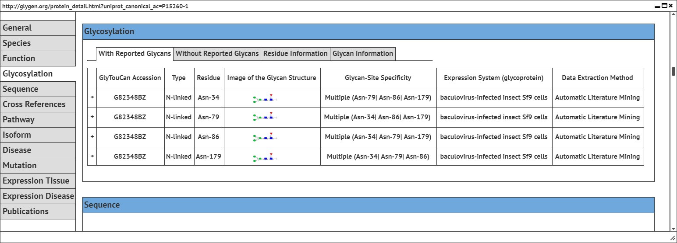

- Site occupancy will be integrated into a new subsection “Residue Information” under the existing section - Glycosylation.

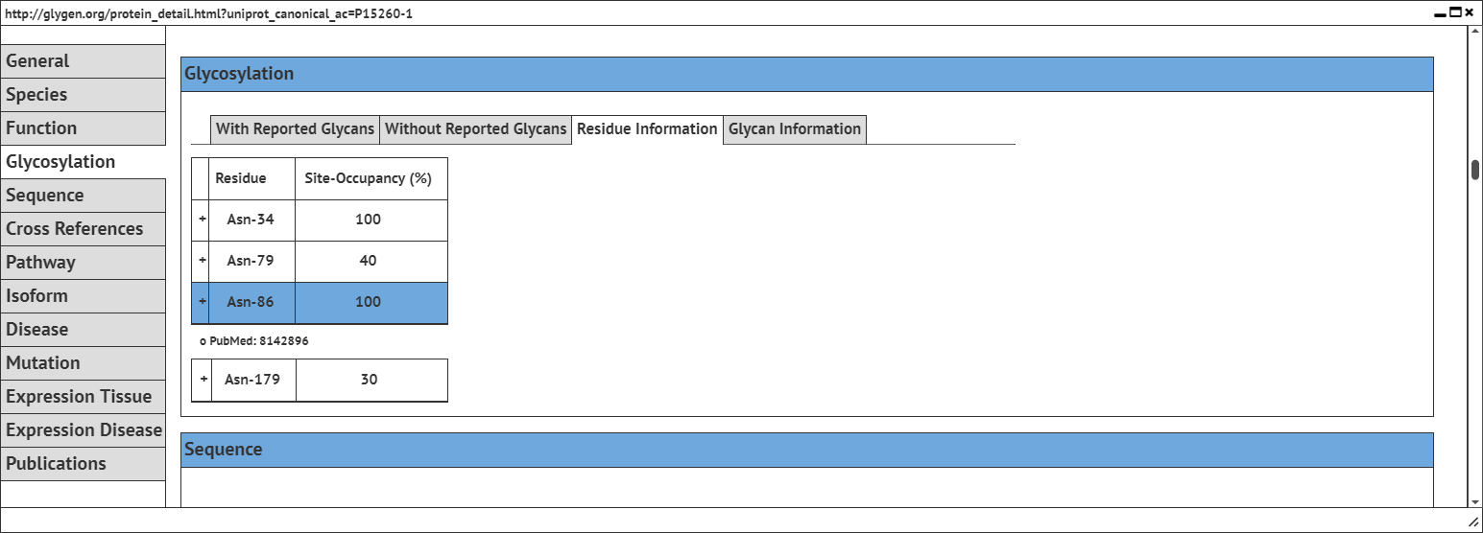

- Information such as “Predominant glycan species” and “negative information” will be represented as literature comments through a new subsection (Glycan Information) under “Glycosylation” section.

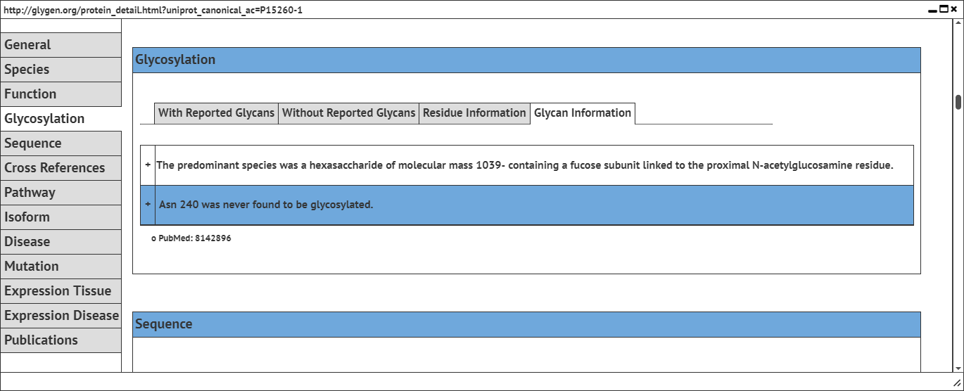

- Glycan function and disease information will be integrated as different subsections under the existing sections - “Function” and “Expression Disease” respectively on GlyGen Protein page.

